#.Pandas:

Data Structures in Pandas:
1.Series – 1D labeled array (like a column in Excel).
-- Collection of labelled data.
How to create series :
s1 = pd.Series([1,2,3,4,5])
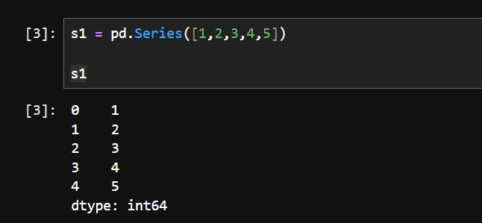
Assigning index:
